Name:S.RAKESH KUMAR
Reg no:192412048
Course code:ECA5604
course name:5G/6G communication
Ex.No:1: Simulation of FDMA in MATLAB Date
Aim: To simulate a Frequency Division Multiple Access (FDMA) system using MATLAB and analyze its communication performance in terms of channel bandwidth, data rate, and signal-to-noise ratio (SNR).
Objective 1:
To simulate an FDMA system by allocating individual frequency channels to multiple users and determine the channel bandwidth assigned to each user.
Output Parameter: Channel Bandwidth (kHz)

Output:
Objective 1:
Program (Matlab Code)
clc; clear; close all;
fs=1000; t=0:1/fs:1;
TBW=600; Users=3;
CBW=TBW/Users;
fc=[100 300 500];
m=sin(2*pi*10*t);
s1=m.*cos(2*pi*fc(1)*t);
s2=m.*cos(2*pi*fc(2)*t);
s3=m.*cos(2*pi*fc(3)*t);
subplot(2,1,1)
plot(t,s1,'r',t,s2,'g',t,s3,'b'),grid on
title('FDMA Channel Allocation'),xlabel('Time (s)'),ylabel('Amplitude') subplot(2,1,2)
bar(1:Users,CBW*ones(1,Users)),grid on
xlabel('Users'),ylabel('Channel Bandwidth (kHz)'),title('Channel Bandwidth per User')

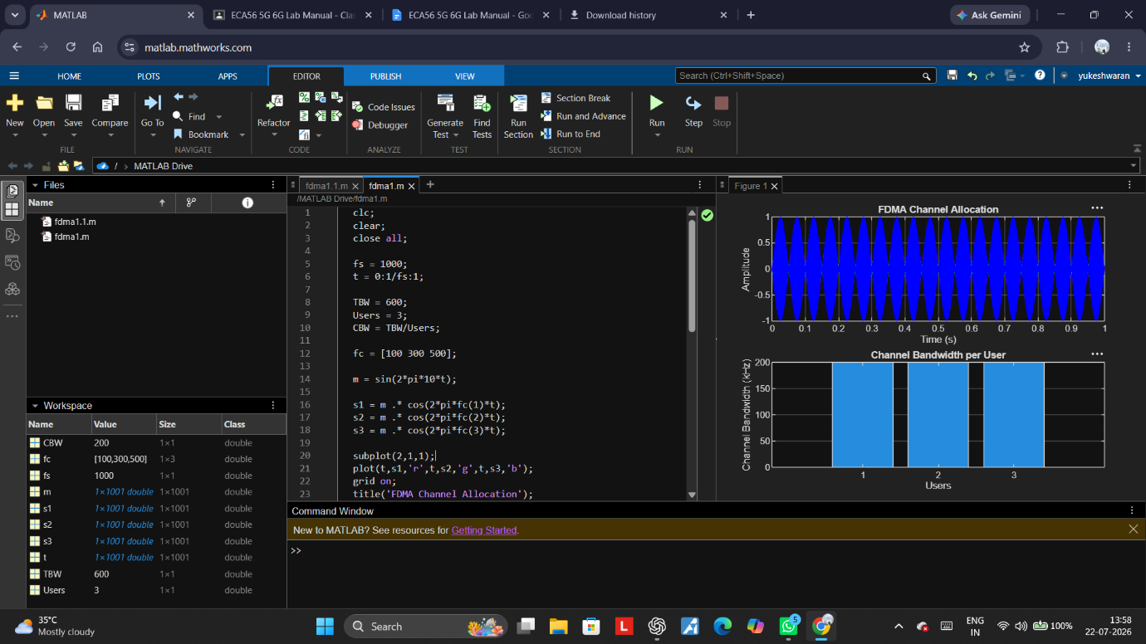

Objective 2:
To calculate the data rate achieved by each user in the FDMA system based on the allocated channel bandwidth.
Output Parameter: Data Rate (kbps)

Objective 2: Matlab Code and Ootput
clc; clear; close all;
BW = 200; % Channel Bandwidth (kHz)
Users = 3;
M = 2; % BPSK Modulation
DataRate = BW*log2(M); % Data Rate (kbps)
Rate = DataRate*ones(1,Users);
disp(' User Data Rate (kbps)')
disp([(1:Users)' Rate'])
figure
bar(1:Users,Rate)
xlabel('Users')
ylabel('Data Rate (kbps)')
title('FDMA Data Rate for Each User')
grid on
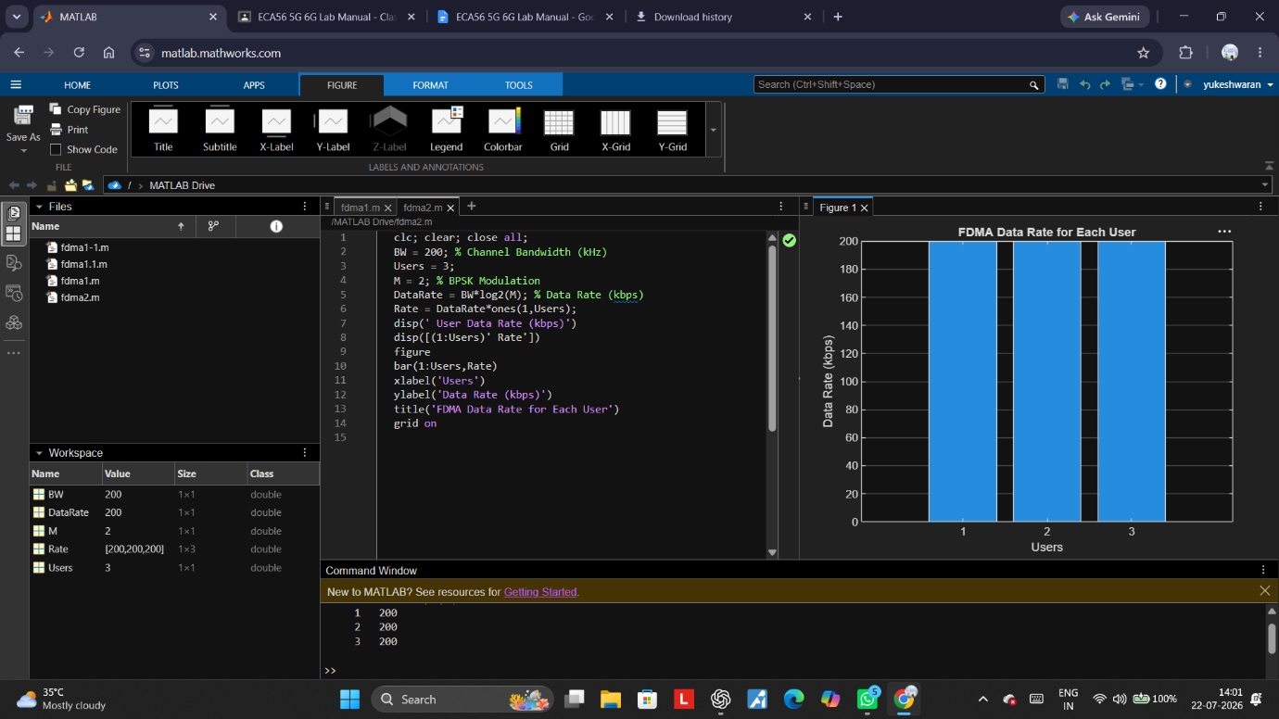

Objective 3:
To evaluate the communication quality of the FDMA system by calculating the Signal-to Noise Ratio (SNR) for different users.
Output Parameter: Signal-to-Noise Ratio (SNR) (dB)

Objective 3: Matlab Code and Ootput
clc; clear; close all;
Ps = 1; % Signal Power (W)
Pn = [0.1 0.05 0.01]; % Noise Power (W)
Users = 1:3;
SNR = 10*log10(Ps./Pn); % SNR in dB
disp('User Noise Power(W) SNR(dB)')
disp([Users' Pn' SNR'])
figure
bar(Users,SNR)
xlabel('Users')
ylabel('SNR (dB)')
title('Signal-to-Noise Ratio of FDMA Users')
grid on
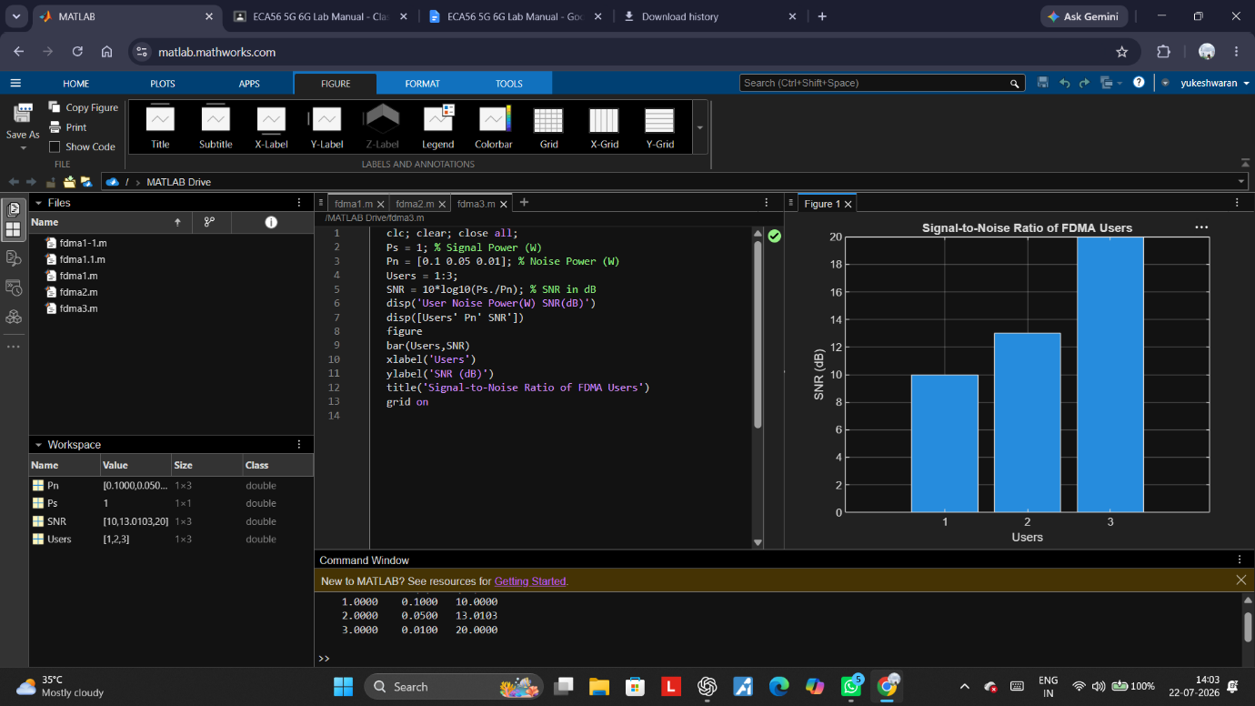
Result:
1. The FDMA system was successfully simulated by allocating separate frequency channels to three users, and the channel bandwidth assigned to each user was determined.
2. The data rate achieved by each user was successfully calculated based on the allocated channel bandwidth, demonstrating equal transmission capacity for all users.
3. The Signal-to-Noise Ratio (SNR) for different users was successfully evaluated, showing that higher SNR values provide better communication quality and reliable data transmission.

